Location and Intensity of Significant Earthquakes
New York State — 1990-2015
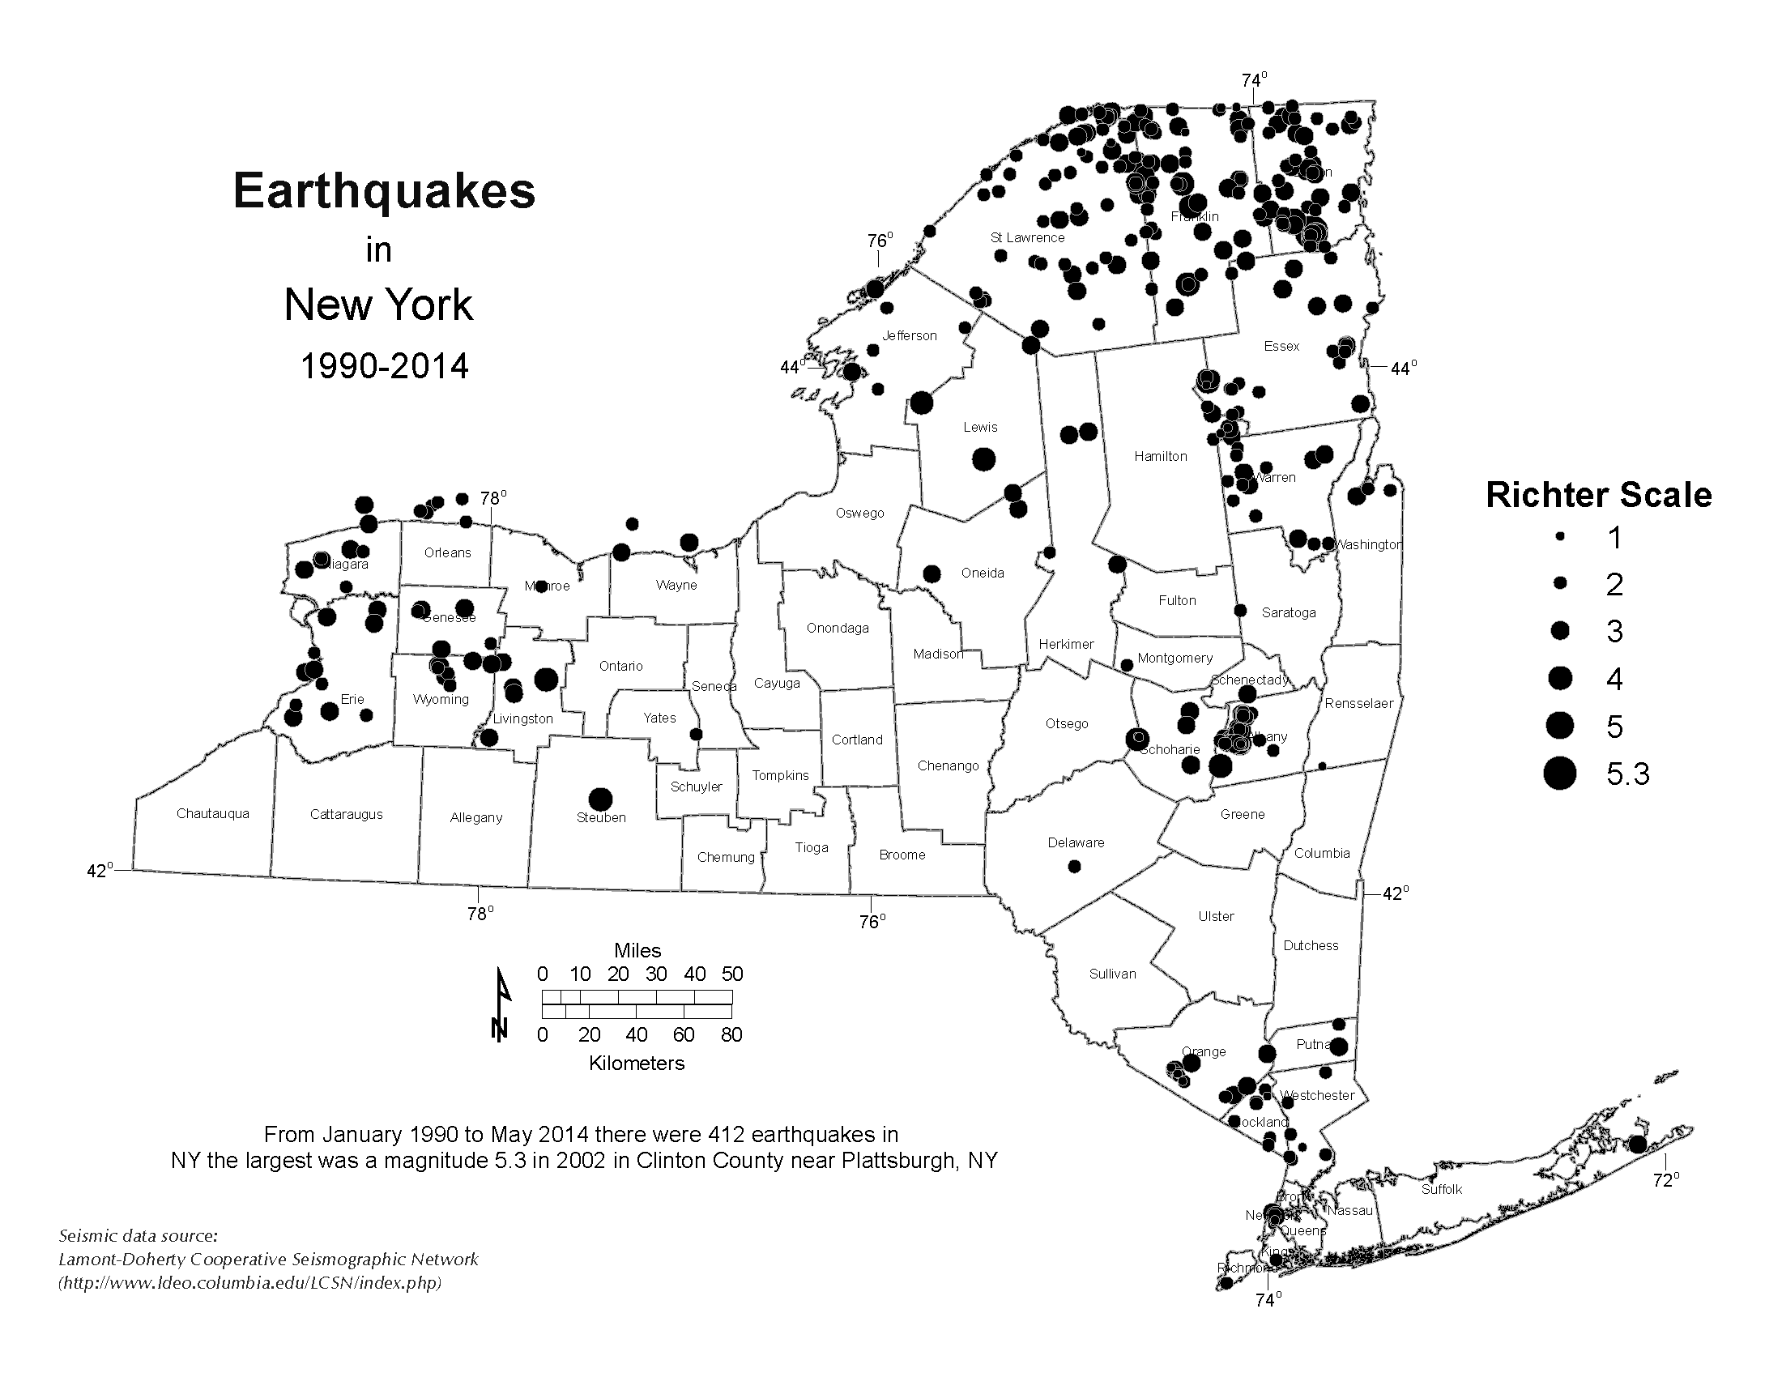
NOTE: The data above are provided by the Lamont-Doherty Earth Observatory (Columbia University) for 1990-2015 and reports 364 events within the civil boundaries of New York State.
Modified Mercalli Intensity vs. Richter Magnitude—Earthquakes are commonly measured in one of two ways.
(1) The Modified Mercalli Intensity scale, in Roman numerals, measures the event in terms of how people and structures react to it. (2) Richter Magnitude, in Arabic numerals, is a measure of the energy released by the earthquake. They can be compared as shown below:
Modified Mercalli  Intensity Scale | Richter Magnitude | Earthquake Effects
I, II | Less than 3.5 | Generally not felt, but recorded.
III-IV | 3.5-5.4 | Often felt, but rarely causes damage.
V-VII | Under 6.0 | At most, slight damage to well-designed buildings. Can cause major damage to poorly constructed buildings over small regions.
VIII-IX | 6.1-6.9 | Can be destructive in areas up to about 100 kilometers across.
X-XI | 7.0-7.9 | Major earthquake. Can cause serious damage over larger areas. Most buildings destroyed.
XII | 8 or greater | Great earthquake. Can cause serious damage in areas several hundred kilometers across.

SOURCE: New York State Education Department, Geological Survey.

