Mineral Resources
New York State — 2015

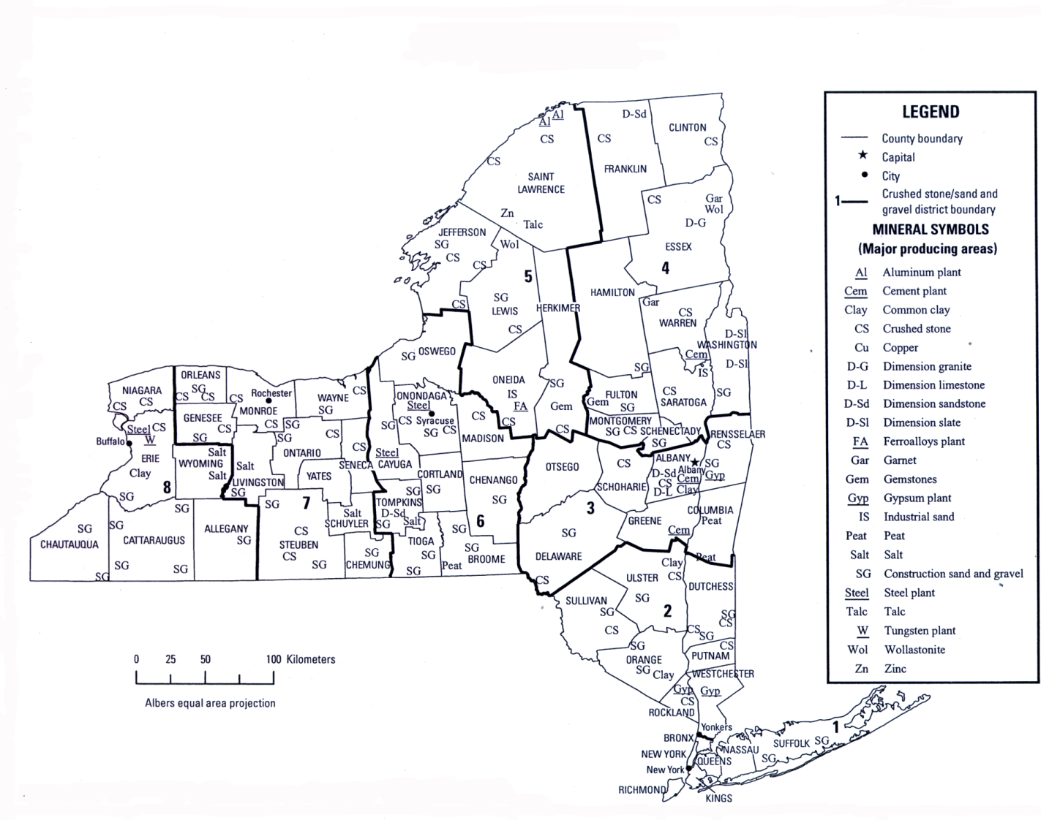

SOURCE: New York State Education Department, Geological Survey.

